*A project report on*

**SECURE DATA TRANSMISSION**

*Submitted by*

**14CO204 – APARNA JOSHI**

**14CO217 – ISHA TARTE**

**14CO216 – HUZAIFA ABBASI**

*In partial fulfilment for the award of the degree of*

**BACHELOR OF TECHNOLOGY**

In

**COMPUTER SCIENCE AND ENGINEERING**



**Department of Computer Science and Engineering**

**National Institute of Technology Karnataka, Surathkal**

**April 2016**

**SECURE**

**DATA TRANSMISSION**

**ABSTRACT:**

The objective of this project is to provide the secure communication among the connected system in the network. It provides the necessary authentication for the file transferring especially images in the network transmission. It consists of three modules namely encryption and decryption module, password authentication module, transferring of the data through network. It provides the user proper and required authentication to the data that has to transmit through network.

By the implementation of the Server­ Client technology we are able to use File Transfer Protocol mechanism and through socket programming the end user is able to send and receive the encrypted and decrypted file in the network respectively. It involves encryption of data at sender’s end and decryption at receiver's end. The encryption and decryption is performed using the same key i.e. symmetric key cryptography. The file transfer is performed using socket programming. So, the project implements socket programming using cryptographic methods.

**INDEX:**

1. INTRODUCTION………………………………………………4
   1. Encryption………………………………………………….4
   2. Plaintext…………………………………………………….4
   3. Ciphertext…………………………………………………..4
   4. Decryption………………………………………………….5
   5. AES Encryption Algorithm………………………………...5
   6. Decryption of the Cipher…………………………………...6
   7. Algorithm Outline………………………………………….7
   8. Optimization of the Cipher…………………………………11
2. IMPLEMENTATION…………………………………………...12
3. SCREENSHOTS………………………………………………...15
   1. Server-Side………………………………………………….15
   2. Client-Side…………………………………………………..17
4. CONCLUSION………………………………………………….21
5. REFERENCES…………………………………………………..22
6. **INTRODUCTION:**
   1. ENCRYPTION**:**

In [cryptography](https://en.wikipedia.org/wiki/Cryptography), **encryption** is the process of encoding messages or information in such a way that only authorized parties can read it. Encryption does not of itself prevent interception, but denies the message content to the interceptor. In an encryption scheme, the intended communication information or message, referred to as plaintext, is encrypted using an encryption algorithm, generating ciphertext that can only be read if decrypted. For technical reasons, an encryption scheme usually uses a pseudo-random encryption key generated by an algorithm. It is in principle possible to decrypt the message without possessing the key, but, for a well-designed encryption scheme, large computational resources and skill are required. An authorized recipient can easily decrypt the message with the key provided by the originator to recipients, but not to unauthorized interceptors.

* 1. PLAIN TEXT:

In [computing](https://en.wikipedia.org/wiki/Computing), **plain text** is the data (e.g. file contents) which represent only [characters](https://en.wikipedia.org/wiki/Character_(computing)) of readable material but not its graphical representation nor other objects (images, etc.). It may also include a limited number of characters that control simple arrangement of text, such as line breaks or tabulation characters. Plain text is different from [formatted text](https://en.wikipedia.org/wiki/Formatted_text), where style information is included, and"binary files" in which some portions must be interpreted as binary objects (encoded integers, real numbers, images, etc.).

The [encoding](https://en.wikipedia.org/wiki/Character_encoding) has traditionally been either [ASCII](https://en.wikipedia.org/wiki/ASCII), sometimes [EBCDIC](https://en.wikipedia.org/wiki/EBCDIC). [Unicode](https://en.wikipedia.org/wiki/Unicode)-based encodings such as[UTF-8](https://en.wikipedia.org/wiki/UTF-8) and [UTF-16](https://en.wikipedia.org/wiki/UTF-16) are gradually replacing the older ASCII derivatives limited to 7 or 8 bit codes.

* 1. CIPHER TEXT:

In [cryptography](https://en.wikipedia.org/wiki/Cryptography), **ciphertext** is the result of [encryption](https://en.wikipedia.org/wiki/Encryption) performed on [plaintext](https://en.wikipedia.org/wiki/Plaintext) using an algorithm, called a [cipher](https://en.wikipedia.org/wiki/Cipher). Ciphertext is also known as encrypted or encoded information because it contains a form of the original plaintext that is unreadable by a human or computer without the proper cipher to decrypt it. [Decryption](https://en.wikipedia.org/wiki/Decryption), the inverse of encryption, is the process of turning ciphertext into readable plaintext. Ciphertext is not to be confused with [codetext](https://en.wikipedia.org/wiki/Codetext) because the latter is a result of a [code](https://en.wikipedia.org/wiki/Code_(cryptography)), not a cipher.

* 1. DECRYPTION:

**Decryption** is the process of taking encoded or encrypted text or other data and converting it back into text that you or the computer can read and understand. This term could be used to describe a method of un-encrypting the data manually or with un-encrypting the data using the proper codes or keys. Data may be encrypted to make it difficult for someone to steal the information. Some companies also encrypt data for general protection of company data and trade secrets. If this data needs to be viewable, it may require decryption. If a decryption passcode or key is not available, special software may be needed to decrypt the data using algorithms to crack the decryption and make the data readable.

* 1. AES ENCRYPTION ALGORITHM:

The **Advanced Encryption Standard** (**AES**), also known as **Rijndael** (its original name), is a specification for the [encryption](https://en.wikipedia.org/wiki/Encryption) of electronic data established by the U.S. [National Institute of Standards and Technology](https://en.wikipedia.org/wiki/National_Institute_of_Standards_and_Technology) (NIST) in 2001.

AES is based on the Rijndael [cipher](https://en.wikipedia.org/wiki/Cipher) developed by two [Belgian](https://en.wikipedia.org/wiki/Belgium) cryptographers, [Joan Daemen](https://en.wikipedia.org/wiki/Joan_Daemen) and [Vincent Rijmen](https://en.wikipedia.org/wiki/Vincent_Rijmen), who submitted a proposal to NIST during the AES selection process. Rijndael is a family of ciphers with different key and block sizes.

* 1. DESCRIPTION OF THE CIPHER

AES is based on a design principle known as a [substitution-permutation network](https://en.wikipedia.org/wiki/Substitution-permutation_network), combination of both substitution and permutation, and is fast in both software and hardware.[[10]](https://en.wikipedia.org/wiki/Advanced_Encryption_Standard#cite_note-10) Unlike its predecessor DES, AES does not use a [Feistel network](https://en.wikipedia.org/wiki/Feistel_network). AES is a variant of Rijndael which has a fixed [block size](https://en.wikipedia.org/wiki/Block_size_(cryptography)) of 128 [bits](https://en.wikipedia.org/wiki/Bit), and a [key size](https://en.wikipedia.org/wiki/Key_size) of 128, 192, or 256 bits. By contrast, the Rijndael specification *per se* is specified with block and key sizes that may be any multiple of 32 bits, both with a minimum of 128 and a maximum of 256 bits.

AES operates on a 4×4 [column-major order](https://en.wikipedia.org/wiki/Column-major_order) matrix of bytes, termed the *state*, although some versions of Rijndael have a larger block size and have additional columns in the state. Most AES calculations are done in a special [finite field](https://en.wikipedia.org/wiki/Finite_field_arithmetic).

For instance, if there are 16 bytes, b0,b1,...,b15, these bytes are represented as this matrix:

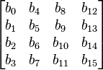

The key size used for an AES cipher specifies the number of repetitions of transformation rounds that convert the input, called the plaintext, into the final output, called the ciphertext. The number of cycles of repetition are as follows:

* 10 cycles of repetition for 128-bit keys.
* 12 cycles of repetition for 192-bit keys.
* 14 cycles of repetition for 256-bit keys.

Each round consists of several processing steps, each containing four similar but different stages, including one that depends on the encryption key itself. A set of reverse rounds are applied to transform ciphertext back into the original plaintext using the same encryption key.

* 1. ALGORITHM OUTLINE:

1. KeyExpansions—round keys are derived from the cipher key using [Rijndael's key schedule](https://en.wikipedia.org/wiki/Rijndael_key_schedule). AES requires a separate 128-bit round key block for each round plus one more.
2. InitialRound
   1. AddRoundKey—each byte of the state is combined with a block of the round key using bitwise xor.
3. Rounds
   1. SubBytes—a non-linear substitution step where each byte is replaced with another according to a [lookup table](https://en.wikipedia.org/wiki/Rijndael_S-box).
   2. ShiftRows—a transposition step where the last three rows of the state are shifted cyclically a certain number of steps.
   3. MixColumns—a mixing operation which operates on the columns of the state, combining the four bytes in each column.
   4. AddRoundKey
4. Final Round (no MixColumns)
   1. SubBytes
   2. ShiftRows
   3. AddRoundKey.

### 

### The SubBytes step

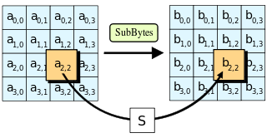

In the SubBytes step, each byte in the state is replaced with its entry in a fixed 8-bit lookup table, *S*; *bij* =*S(aij)*.

In the SubBytes step, each byte  in the *state* matrix is replaced with a SubByte  using an 8-bit[substitution box](https://en.wikipedia.org/wiki/Substitution_box), the [Rijndael S-box](https://en.wikipedia.org/wiki/Rijndael_S-box). This operation provides the non-linearity in the [cipher](https://en.wikipedia.org/wiki/Cipher). The S-box used is derived from the [multiplicative inverse](https://en.wikipedia.org/wiki/Multiplicative_inverse) over [**GF**](https://en.wikipedia.org/wiki/Finite_field)(*28*), known to have good non-linearity properties. To avoid attacks based on simple algebraic properties, the S-box is constructed by combining the inverse function with an invertible affine [transformation](https://en.wikipedia.org/wiki/Affine_transformation). The S-box is also chosen to avoid any fixed points (and so is a [derangement](https://en.wikipedia.org/wiki/Derangement)), i.e., , and also any opposite fixed points, i.e., . While performing the decryption, Inverse SubBytes step is used, which requires first taking the affine transformation and then finding the multiplicative inverse (just reversing the steps used in SubBytes step).

### The ShiftRows step

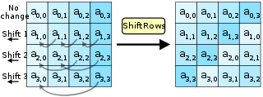

In the ShiftRows step, bytes in each row of the state are shifted cyclically to the left. The number of places each byte is shifted differs for each row.

The ShiftRows step operates on the rows of the state; it cyclically shifts the bytes in each row by a certain [offset](https://en.wikipedia.org/wiki/Offset_(computer_science)). For AES, the first row is left unchanged. Each byte of the second row is shifted one to the left. Similarly, the third and fourth rows are shifted by offsets of two and three respectively. For blocks of sizes 128 bits and 192 bits, the shifting pattern is the same. Row n is shifted left circular by n-1 bytes. In this way, each column of the output state of the ShiftRows step is composed of bytes from each column of the input state. (Rijndael variants with a larger block size have slightly different offsets). For a 256-bit block, the first row is unchanged and the shifting for the second, third and fourth row is 1 byte, 3 bytes and 4 bytes respectively—this change only applies for the Rijndael cipher when used with a 256-bit block, as AES does not use 256-bit blocks. The importance of this step is to avoid the columns being linearly independent, in which case, AES degenerates into four independent block ciphers.

### The MixColumns step

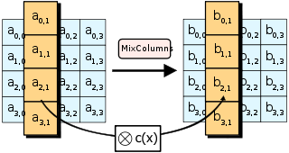

In the MixColumns step, each column of the state is multiplied with a fixed polynomial *c(x)*.

In the MixColumns step, the four bytes of each column of the state are combined using an invertible [linear transformation](https://en.wikipedia.org/wiki/Linear_transformation). The MixColumns function takes four bytes as input and outputs four bytes, where each input byte affects all four output bytes. Together with ShiftRows, MixColumns provides [diffusion](https://en.wikipedia.org/wiki/Diffusion_(cryptography)) in the cipher.

During this operation, each column is transformed using a fixed matrix (matrix multiplied by column gives new value of column in the state):

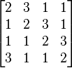

Matrix multiplication is composed of multiplication and addition of the entries. Entries are 8 bit bytes treated as coefficients of polynomial of order x7. Addition is simply XOR. Multiplication is modulo irreducible polynomial x8+x4+x3+x+1. If processed bit by bit then after shifting a conditional [XOR](https://en.wikipedia.org/wiki/Exclusive_or) with 0x1B should be performed if the shifted value is larger than 0xFF (overflow must be corrected by subtraction of generating polynomial). These are special cases of the usual multiplication in **GF**(*28*).

In more general sense, each column is treated as a polynomial over **GF**(*28*) and is then multiplied modulo x4+1 with a fixed polynomial c(x) = 0x03 · x3 + x2 + x + 0x02. The coefficients are displayed in their [hexadecimal](https://en.wikipedia.org/wiki/Hexadecimal) equivalent of the binary representation of bit polynomials from **GF**(2)[x]. The MixColumns step can also be viewed as a multiplication by the shown particular [MDS matrix](https://en.wikipedia.org/wiki/MDS_matrix) in the [finite field](https://en.wikipedia.org/wiki/Finite_field) **GF**(*28*). This process is described further in the article [Rijndael mix columns](https://en.wikipedia.org/wiki/Rijndael_mix_columns).

### The AddRoundKey step

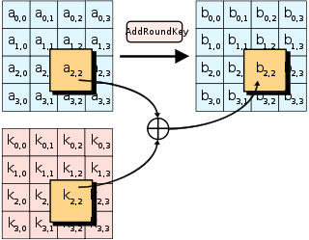

In the AddRoundKey step, each byte of the state is combined with a byte of the round subkey using the [XOR](https://en.wikipedia.org/wiki/Exclusive_or)operation (⊕).

In the AddRoundKey step, the subkey is combined with the state. For each round, a subkey is derived from the main [key](https://en.wikipedia.org/wiki/Key_(cryptography)) using [Rijndael's key schedule](https://en.wikipedia.org/wiki/Rijndael_key_schedule); each subkey is the same size as the state. The subkey is added by combining each byte of the state with the corresponding byte of the subkey using bitwise [XOR](https://en.wikipedia.org/wiki/Exclusive_or).

### OPTIMIZING THE CIPHER

On systems with 32-bit or larger words, it is possible to speed up execution of this cipher by combining theSubBytes and ShiftRows steps with the MixColumns step by transforming them into a sequence of table lookups. This requires four 256-entry 32-bit tables, and utilizes a total of four kilobytes (4096 bytes) of memory — one kilobyte for each table. A round can then be done with 16 table lookups and 12 32-bit exclusive-or operations, followed by four 32-bit exclusive-or operations in the AddRoundKey step.

If the resulting four-kilobyte table size is too large for a given target platform, the table lookup operation can be performed with a single 256-entry 32-bit (i.e. 1 kilobyte) table by the use of circular rotates.

Using a byte-oriented approach, it is possible to combine the SubBytes, ShiftRows, and MixColumns steps into a single round operation.

1. **IMPLEMENTATION**:

The above project mainly contains four main modules.

1. Server

2. Client

3. Encryption

4. Decryption

Server: Server is a process that serves the requests of clients. The client requests that some action be performed and the server performs the action returning the result to the client. A server always waits for the request from the clients. When a client first attempts to establish a connection to the server, the server can accept or deny the connection. If the connection is accepted then the client and server communicate through sockets as if they were doing file I\O. When the purpose of connection is served either the client or server may close file I\O. When the purpose of connection is served either the client or server may close the connection. If anyone closes the connection the connection is closed on both sides.

The Server consists of two functionalities.

* File Transfer
* Image Transfer

Server always waits for the client’s request. When a client makes any request the server calls the File Transfer module or Image Transfer module depending on what the server chooses to send. File Transfer module transfers the file from source to destination system while Image Transfer module transfers the image from source to the destined IP address.

Client: The client always interacts with the server. The client can send and/or receive the files/images from the server. It has two modules.

* Receive file
* Receive image

After client gets connected to the he may choose receive options from the panel. The client enters the filename, the name by which the received file will be stored in the current working directory and the key. If the key is the same as the one entered by the server then the connection is established and the file is received, decrypted and saved.

Encryption: The server uses this module. Actual encryption using Advanced Encryption Algorithm (AES) takes place in this module. The input for this module is the source file from the file selector, name and key. It takes the source file and encrypts the data and sends to the destination IP.

Decryption: The client uses this module. Actual decryption takes place in this module. The input for this module is the source filename, destination file name and key. It takes the source file and decrypts the data and stores in the destination file.

1. **SCREENSHOTS:**
   1. Server Side:

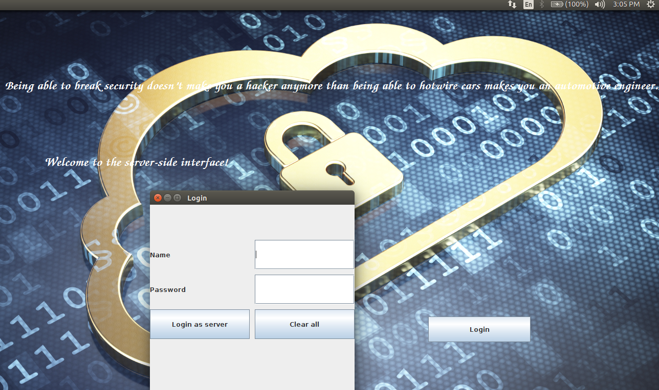



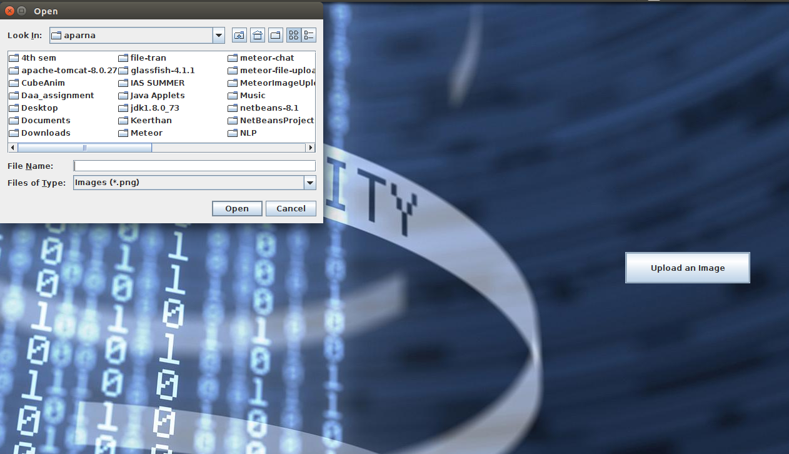

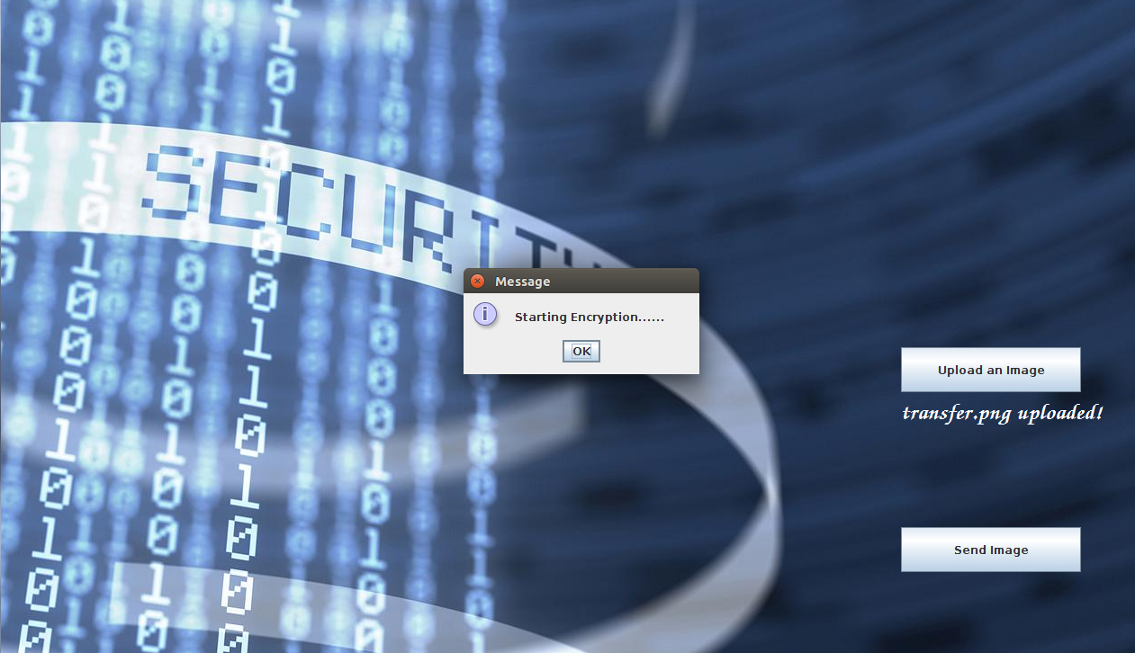

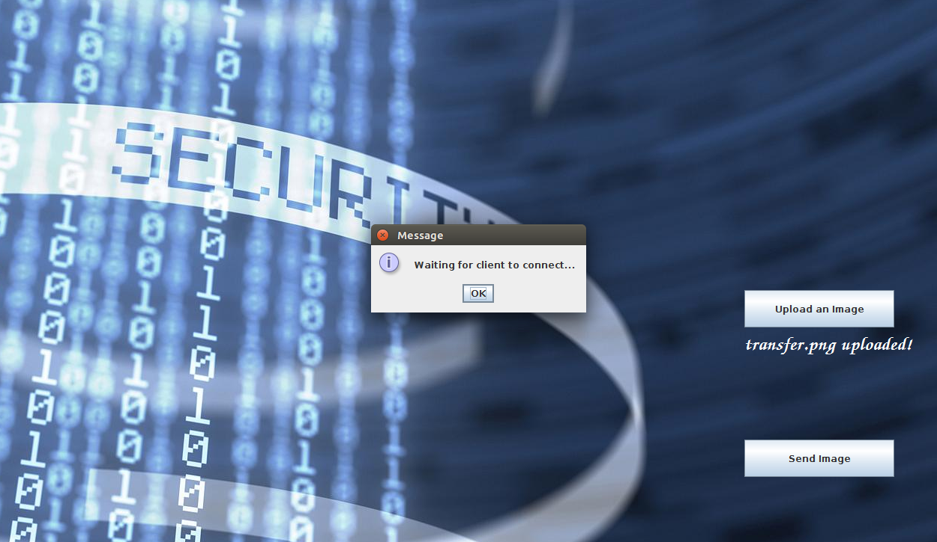

* 1. Client Side:



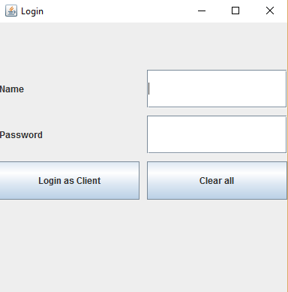



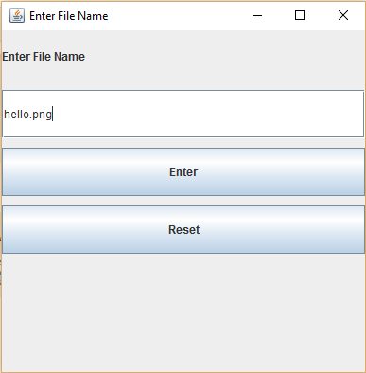



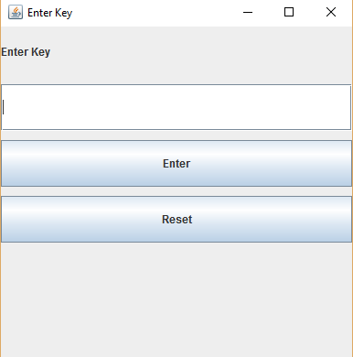

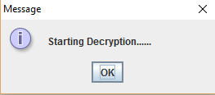

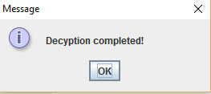

1. **CONCLUSION:**

Advanced Encryption Standard (AES) is one of the most frequently used and most secure encryption algorithms available today. It is publicly accessible, and it is the cipher which the NSA uses for securing documents with the classification "top secret". As of today, no practicable attack against AES exists. Therefore, AES remains the preferred encryption standard for governments, banks and high security systems around the world. The project ensures secure data transmission from server to client through socket programming.

1. **REFERENCES**

<https://www.boxcryptor.com/en/encryption>

<https://en.wikipedia.org/wiki/Advanced_Encryption_Standard>